1. Once you have completed the installation, you can easily to launch RIDE by command line.



1. Select New Project to create a project dictionary.

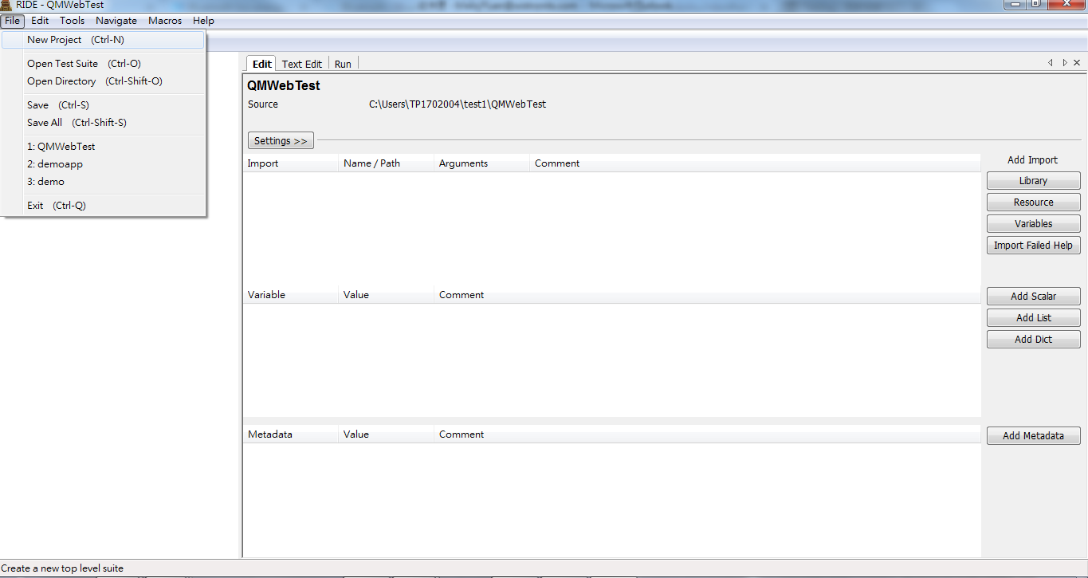

Select Dictionary.

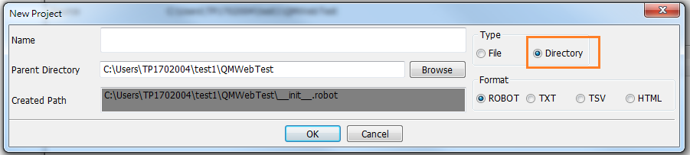

1. In Project Edit view, import the external library you need. (In web case, import Selenium2Library)

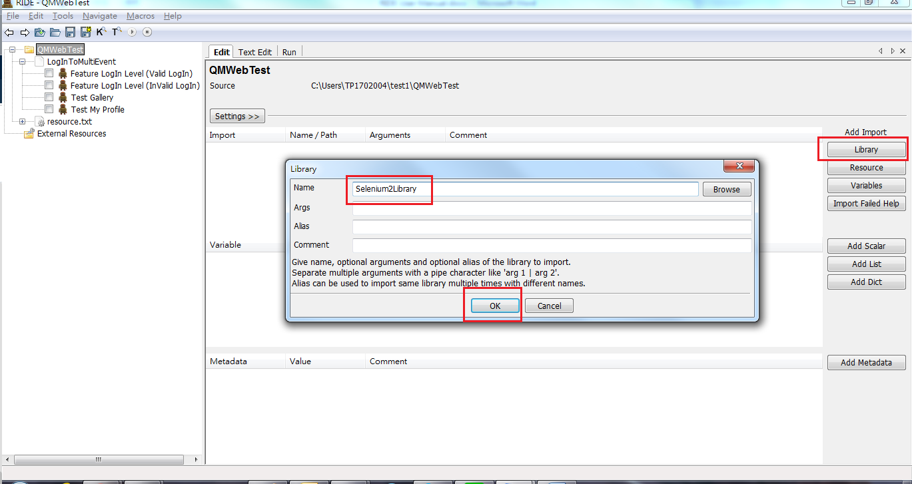

1. Check on the Library import success or not. (Red text means import fail)

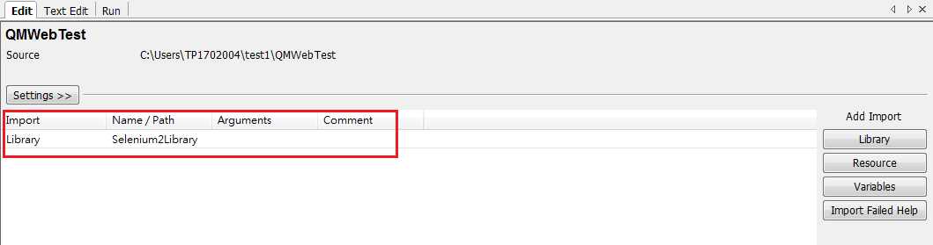

1. Right click on the project folder to select new suite.

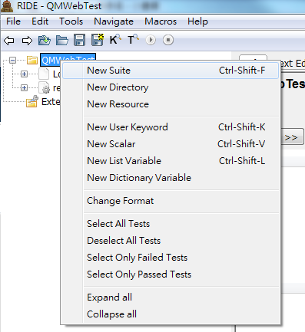

1. Create a test case by right click on Test Suite.

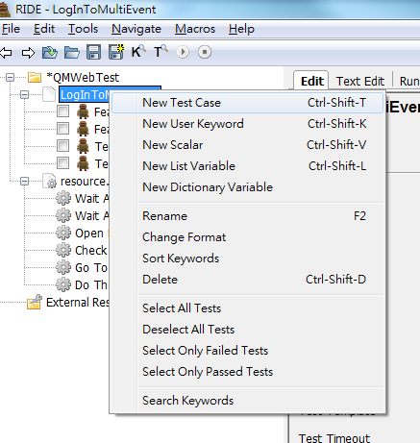

1. Enter F5 to bring up the keyword list.

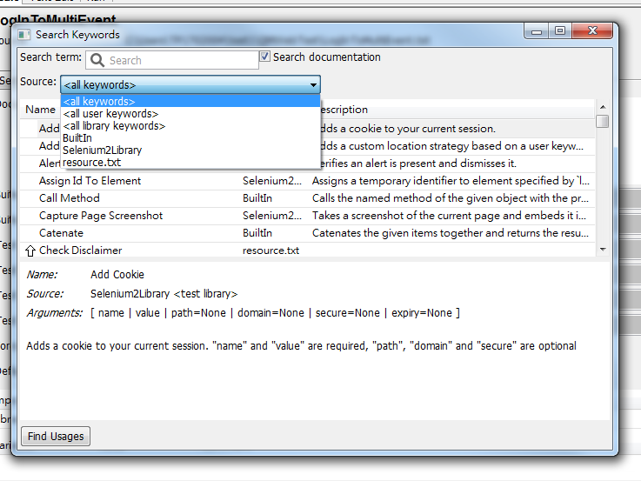

1. Use the key word to create the test case, use resource.txt to create some customize keyword to make the test case readable.

